Part 3;DNS server setup using BIND
Install bind using the following command; sudo dnf install bind
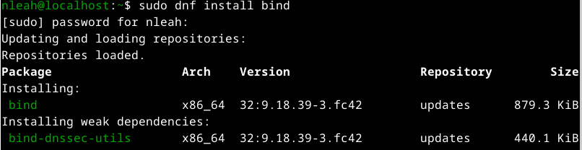
To edit configuration file use the command; nano /etc/named.conf
To edit zone file use the command; nano /var/named/zonefilename
NOTE; Configuration Files
The primary configuration file is /etc/named.conf. It contains global settings and includes zone
configurations. Zone files are stored in the /var/named/ directory by default.
Uncomment the listen-on line and add the IP address of your DNS server.
Uncomment the allow-query line and add the IP address range of your local network.
For example, if your DNS server has the IP address 192.168.1.10 and your local network is
192.168.1.0/24, the following configuration would be valid:
options {
listen-on port 53 { 192.168.1.10; };
allow-query { 192.168.1.0/24; };
To view the content use the command; cat /var/named/zonefilename
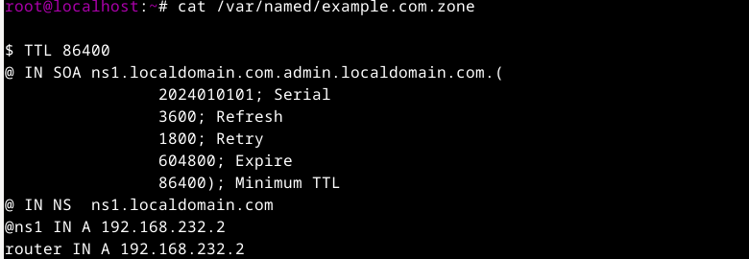
Start and Enable BIND use the command; sudo systemctl start named and sudo systemctl enable name
Test your DNS server configuration using the command; dig example.com
